41.43: From Section 38.6: 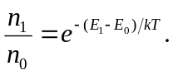We need to know the difference in energy between the 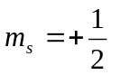and 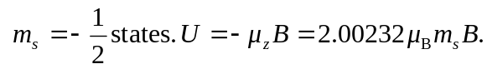
So 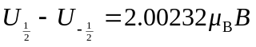
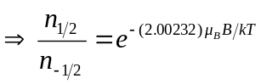
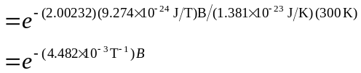
a) 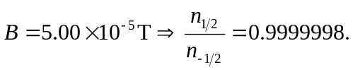
b) 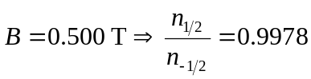
c) 